Module 3 Introduction to OOPS Programming
Introduction to C++
1. What are the key differences between Procedural Programming and Object-Oriented Programming (OOP)?

Aspect | Procedural Programming | Object-Oriented Programming
Approach | Focuses on functions/procedures | Focuses on objects & classes
Data Handling | Data is mostly separate from functions | Data and methods are encapsulated together
Reusability | Limited (via functions) | High (inheritance, polymorphism)
Security | Less secure | More secure due to encapsulation
Examples | C, Pascal | C++, Java, Python

2. List and explain the main advantages of OOP over POP.
Advantages of Object-Oriented Programming (OOP) over Procedural-Oriented Programming (POP) are as follows:
- Encapsulation – Combines data and functions into a single unit (class), improving data security.
- Data Hiding – Internal details are hidden using access specifiers, reducing misuse of data.
- Reusability – Code can be reused through inheritance, saving time and effort.
- Modularity – Programs are divided into independent objects, making them easier to manage.
- Flexibility – Polymorphism allows the same function to behave differently in different situations.
- Easy Maintenance – Changes in one part of the program do not affect the entire system.
- Scalability – Suitable for large and complex software projects.

3. Explain the steps involved in setting up a C++ development environment.
Steps to Set up a C++ Development Environment are:
- Install a C++ Compiler
  - Windows: Install MinGW or MSVC (Visual Studio)
  - Linux: Install GCC (g++)
  - macOS: Install Xcode Command Line Tools
- Install an IDE or Code Editor
  - Examples: Visual Studio, Code::Blocks, Dev-C++, VS Code
- Configure the Compiler Path
  - Set the compiler path in the system Environment Variables so the compiler runs from the command line.
- Create a C++ Program
  - Write a simple program using a .cpp file (e.g., main.cpp).
- Compile the Program
  - Use the compiler (e.g., g++ main.cpp -o main).
- Run the Program
  - Execute the compiled file to check the output.

4. What are the main input/output operations in C++? Provide examples.
C++ uses the iostream library for input and output operations.
1. Output Operation (cout) - Used to display output on the screen.
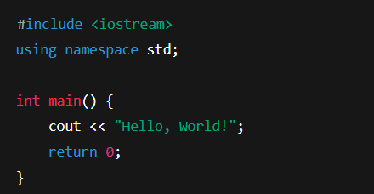

2. Input Operation (cin) - Used to take input from the user.
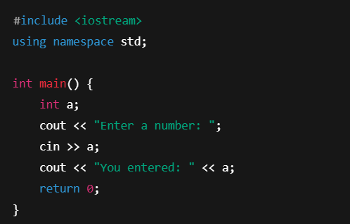

Variables, Data Types, and Operators
1. What are the different data types available in C++? Explain with examples.
a) Basic (Primitive) Data Types
- int – stores integers = E.g. int a = 10;
- float – stores decimal numbers = E.g. float b = 5.5;
- double – stores large decimal values = E.g. double c = 12.345;
- char – stores a single character = E.g. char ch = 'A';
- bool – stores true/false = E.g. bool flag = true;
b) Derived Data Types
- Array = E.g. int arr[3] = {1, 2, 3};
- Pointer = E.g. int *p;
- Function
c) User-defined Data Types
- struct, union, enum, class
E.g. struct Student {
int id;
};

2. Explain the difference between implicit and explicit type conversion in C++.
Implicit Type Conversion
- Automatically performed by the compiler.
- Converts smaller data type to larger data type.
- No data loss generally occurs.
Example:
int a = 10;
double b = a; // implicit conversion

Explicit Type Conversion
- Performed manually by the programmer using type casting.
- Converts larger data type to smaller data type.
- Data loss may occur.
Example:
double x = 5.5;
int y = (int)x; // explicit conversion

3. What are the different types of operators in C++? Provide examples.

- Arithmetic Operators – + - * / %
Example: c = a + b;
- Relational Operators – == != > < >= <=
Example: a > b
- Logical Operators – && || !
Example: a && b
- Assignment Operators – = += -= *=
Example: a += 5;
- Increment/Decrement Operators – ++ --
Example: a++;
- Bitwise Operators – & | ^ << >>
Example: a & b

4. Explain the purpose and use of constants and literals in C++.
Constants
- Fixed values that cannot be changed during program execution.
- Declared using const keyword.
Example:
const int MAX = 100;
Literals
- Constant values assigned directly to variables.
- Examples include integer, float, character, and string literals.
Example:
int a = 10;
char ch = 'A';

Control Flow Statements

1. What are conditional statements in C++? Explain if-else and switch.
Conditional statements control the flow of execution based on conditions.
if-else Statement
- Executes code when condition is true or false.
if (a > b)
cout << "A is greater";
else
cout << "B is greater";
switch Statement
- Used when multiple choices are available.
switch(choice) {
case 1: cout << "One"; break;
case 2: cout << "Two"; break;
}

2. Difference between for, while, and do-while loops in C++.
Loop | Condition Check | Executes At Least Once
for | Before loop | No
while | Before loop | No
do-while | After loop | Yes

3. How are break and continue used in loops?
break
- Terminates the loop immediately.
if(i == 5)
break;
continue
- Skips current iteration and moves to next.
if(i == 5)
continue;

4. Explain nested control structures with an example.
Nested control structures mean one control statement inside another.
Example:
if(a > 0) {
for(int i = 0; i < a; i++) {
cout << i;
}
}

Functions and Scope

1. What is a function in C++?
A function is a block of code that performs a specific task.
Declaration: tells compiler about function
Definition: contains function body
Calling: executes the function

2. Scope of variables in C++. Local vs Global
Local Variables
- Declared inside a function.
- Accessible only within that function.
Global Variables
- Declared outside all functions.
- Accessible throughout the program.

3. Explain recursion in C++ with an example.
Recursion is a function calling itself.
Example:
int fact(int n) {
if(n == 0)
return 1;
return n * fact(n - 1);
}

4. What are function prototypes? Why are they used?
Function prototypes declare a function before its use.
Purpose:
- Helps compiler check correct function usage.
- Avoids errors.
Example:
int add(int, int);

Arrays and Strings
1. What are arrays? Difference between 1D and 2D arrays.
Array stores multiple values of same data type.
- 1D Array: Single row
int a[5];
- 2D Array: Rows and columns
int a[2][3];

2. Explain string handling in C++.
Strings are sequences of characters.
- Using char arrays
- Using string class
Example:
string name = "C++";

3. Array initialization (1D & 2D).
1D Array:
int a[3] = {1, 2, 3};
2D Array:
int a[2][2] = {{1,2},{3,4}};

4. String operations and functions in C++.
Common functions:
- strlen() – length
- strcpy() – copy
- strcat() – concatenate
- strcmp() – compare

Introduction to OOP
1. Key concepts of OOP
- Class
- Object
- Encapsulation
- Inheritance
- Polymorphism
- Abstraction

2. Classes and objects with example.
Class: Blueprint
Object: Instance of class
class Student {
public:
int id;
};
Student s1;

3. What is inheritance in C++?
Inheritance allows one class to acquire properties of another class.
class A {};
class B : public A {};

4. What is encapsulation? How is it achieved?
Encapsulation binds data and functions together.
Achieved by:
- Using classes
- Access specifiers (private, public)

